UNITED STATES

SECURITIES AND EXCHANGE COMMISSION

Washington, D.C. 20549

SCHEDULE 14A

(RULE 14a-101)

SCHEDULE 14A INFORMATION

Proxy Statement Pursuant to Section 14(a) of the

Securities Exchange Act of 1934

Filed by the Registrant ☒

Filed by a Party other than the Registrant ☐

Check the appropriate box:

- Preliminary Proxy Statement

- Confidential, for Use of the Commission Only (as permitted by Rule 14a-6(e)(2))

- Definitive Proxy Statement

- Definitive Additional Materials

- Soliciting Material Pursuant to §240.14a-12

SolarEdge Technologies, Inc.

(Name of Registrant as Specified In Its Charter)

(Name of Person(s) Filing Proxy Statement, if other than the Registrant)

Payment of Filing Fee (Check the appropriate box):

☒

No fee required.

☐

Fee computed on table below per Exchange Act Rules 14a-6(i)(1) and 0-11.

  - Title of each class of securities to which transaction applies:

  - Aggregate number of securities to which transaction applies:

  - Per unit price or other underlying value of transaction computed pursuant to Exchange Act Rule 0-11 (Set forth the amount on which the filing fee is calculated and state how it was determined):

  - Proposed maximum aggregate value of transaction:

  - Total fee paid:

- Fee paid previously with preliminary materials.

- Check box if any part of the fee is offset as provided by Exchange Act Rule 0-11(a)(2) and identify the filing for which the offsetting fee was paid previously. Identify the previous filing by registration statement number, or the form or schedule and the date of its filing.

  - Amount Previously Paid:

  - Form, Schedule or Registration Statement No.:

  - Filing Party:

  - Date Filed:


Your Vote Counts!

SOLAREDGE TECHNOLOGIES, INC.

2026 Annual Meeting To Be Held On June 3, 2026
Vote by June 2, 2026

11:59 PM ET



SOLAREDGE TECHNOLOGIES, INC.

1 HAMADA ST.

HERZLIYA PITUACH 4673335

ISRAEL

V94202-P50803


You invested in SOLAREDGE TECHNOLOGIES, INC. and it’s time to vote!

You have the right to vote on proposals being presented at the Annual Meeting. This is an important notice regarding the availability of proxy materials for the 2026 Annual Meeting of Stockholders to be held on June 3, 2026.

Get informed before you vote

View the 2026 Notice and Proxy Statement and 2025 Annual Report online OR you can receive a free paper or email copy of the proxy materials by requesting them prior to May 20, 2026. If you would like to view the proxy materials online, have the control number that is printed in the box below and visit: www.ProxyVote.com. If you would like to request a paper or email copy of the proxy materials for this and/or future stockholder meetings, you may (1) visit www.ProxyVote.com, (2) call 1-800-579-1639 or (3) send an email to sendmaterial@proxyvote.com. If sending an email, please include your control number (indicated below) in the subject line. Unless requested, you will not otherwise receive a paper or email copy of the proxy materials. There is no charge for requesting a paper or email copy of the proxy materials.

How to access Proxy Materials electronically or sign up for electronic delivery and donate to Conservation International in only three easy steps:

- Go to www.ProxyVote.com

- Type in the 16-digit control number (in the box below) and click ‘Get Started’

- On the upper right side, click on ‘Delivery Settings’

Proxy materials and other stockholder communications will be sent to the email address provided. E-delivery will begin with the next communication. Your enrollment will remain in effect as long as you are a stockholder and your email account is active or until you choose to cancel.


For complete information and to vote, visit www.ProxyVote.com

Control #

Smartphone users

Point your camera here and

vote without entering a
control number


Vote in Person at the Meeting*


June 3, 2026

9:00 AM Eastern Time

200 Park Avenue, New York

NY 10166-01936

*Please check the meeting materials for any special requirements for meeting attendance. At the meeting, you will need to request a ballot to vote these shares.

Vote at www.ProxyVote.com

THIS IS NOT A VOTABLE BALLOT

This is an overview of the more complete proxy materials that

are available to you on the Internet. You may view the proxy
materials online at www.ProxyVote.com or easily request a paper
or email copy as described on the reverse side. We encourage
you to access and review all of the important information
contained in the proxy materials before voting.

 |  |  |  | Board
Voting Items |  |  |  | Recommends
1. | Election of Directors
 | Nominees:
1a. | Avery More |  |  | For
1b. | Gilad Almogy |  |  | For
1c. | Betsy Atkins |  |  | For
1d. | Dana Gross |  |  | For
1e. | Guy Gecht |  |  | For
1f. | Yehoshua (Shuki) Nir |  |  | For
1g. | Yoram Tietz |  |  | For
2. | Ratification of the appointment of Kost Forer Gabbay & Kasierer, a member of EY Global as the Company’s
 | independent registered public accounting firm for the year ending December 31, 2026. |  |  | For
3. | Approval of, on an advisory and non-binding basis, the compensation of our named | executive officers (the
 | “Say-on-Pay” vote). |  |  | For
4. | Approval of the amendment to the Company’s Restated Certificate of Incorporation to limit the liability of certain
 | officers as permitted by law. |  |  | For
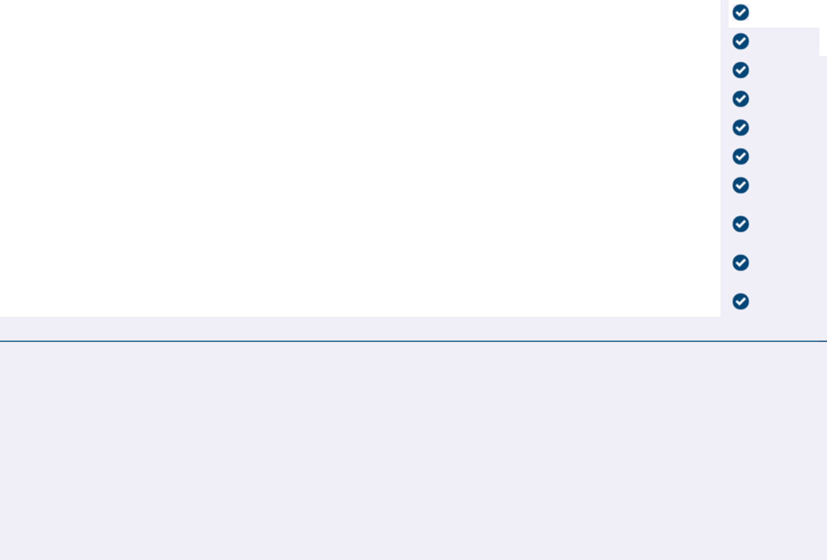

NOTE: Such other business as may properly come before the meeting or any adjournment or postponement thereof.

Prefer to receive an email instead? While voting on www.ProxyVote.com, be sure to click “Delivery Settings”.

V94203-P50803

